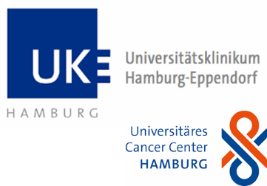
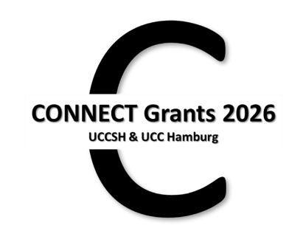
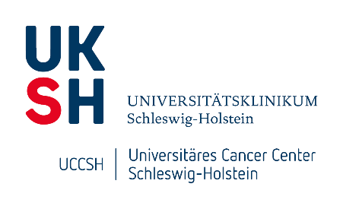

Application form – CONNECT Grants 2026

Funding Period: January 1st until December 31st, 2026
Please complete this form for your CONNECT Grant application.
Please submit the signed application and your CV as a coherent PDF by e-mail to ucch.science.info@uke.de.
Submission Deadline: September 15th, 2025
The application should be written in English, font Calibri 12 pt., and should not exceed 4 pages excluding references.

Study Project Title
Please click here to type your project title.

Applicants
[Team up with partners (teams from 2 to 4 researchers are eligible) from the respective other center (UCCSH or UCC Hamburg).]

From UCCSH / UKSH
 | Names (incl. titles) | E-mail-addresses | Positions | Affiliations (incl. City) | Dates of doctorates
1 | ______ | ______ | ______ | ______ | ______
2 | ______ | ______ | ______ | ______ | ______

From UCC Hamburg / UKE
 | Names (incl. titles) | E-Mailaddresses | Positions | Affiliations | Dates of doctorates
1 | ______ | ______ | ______ | ______ | ______
2 | ______ | ______ | ______ | ______ | ______

Summary (max. 200 words)
Please click here to write your summary.

Current State of Research in the Field/ Background
Please click here to describe the current state of research.

Own Previous Work
[Please indicate expertise and publications each partner brings into the tandem.]
Please click here to describe your previous work.

Work Plan
[Please outline the planned experiments including a specific timeline and contribution of each partner. For CS: please indicate research times and, if applicable, clinical release times as confirmed in the LoS by your department head for the project.]
Please click here to describe your work plan.

Methodological Approaches
[Please indicate the use of infrastructure, platforms, and technologies on the two campi or elsewhere.]
Please click here to describe your methodological approaches.

Added Value/ Focus Area
[Please refer to the respective focus area into which the proposal fits, explain the added value for our NORD consortium and future potential of your joint project.]
UCCSH | UCC Hamburg
☐ Biomarker/Minimal Residual Disease | ☐ Dissemination & Metastasis incl. Liquid Biopsy
☐ Metastasis/Dissemination | ☐ Prostate Cancer
☐ Inflammation and Cancer | ☐ GI & Immuno-Oncology
☐ Immunotherapy/Tumor Immunology | ☐ Neuro-Oncology
☐ Precision Oncology & Resistance to Therapy | ☐ Hematology & Cellular Therapy
☐ Health Care Research
Please click here to explain your added value.

Financial Plan
(up to 50,000 €, divided equally between the partners according to purpose)
[Detailed budget justification: personnel, consumables; distribution among the applicants.]
Please click here to explain your financial plan.

References
Please click here to add your references.

Appendices:
[CVs and letters of support can be added as separate PDFs but must be included in the final application PDF file.]

CVs of all applicants, including publications & third-party funding.

Letters of support of both participating departments (Kiel/ Lübeck and Hamburg) by department heads, including confirmation of clinical release times if applicable.

Contacts:
UCC Hamburg: Dr. Natascha Kömm (n.koemm@uke.de) &
Dr. Inga Melzer (i.melzer@uke.de)
UCCSH: Prof. Susanne Sebens (susanne.sebens@uksh.de),
Prof. Timo Gemoll (timo.gemoll@uksh.de) &
Dr. Sarah Habig (sarah.habig@uksh.de)

